**CO24497: PROGRAMMING PACTICES**

**Assignment- #6**

**Q1.** Write a python program to print the contents of a directory using OS module. Search online for the function which does that.

**Ans**

import os

import time

path = 'C:\Users\gs211\OneDrive\Documents'

list__files = os.listdir(path)

#print(list__files)

**Q2.** Write a python program to play any audio file.(Using an external module)

**Ans**

# import required module

from playsound import playsound

# for playing note.wav file

p=playsound('C:\\Users\\gs211\\OneDrive\\Documents\\GitHub\\shivnand_new\\Arijit_Singh_Mitra_Re.mp3')

p.start()

print('playing sound using playsound')

**Q3.** Using Pandas read any CSV file and display first five rows of that file

**Ans**

import pandas as pd

dataset=pd.read_csv("machine-readable-business-employment-data-june-2022-quarter.csv")

print(dataset.head())

**Q4.** Write a python program to find the average of the numbers entered by the user.

N=int(input("enter total number"))

sum=0

for x in range(N):

a=int(input("enter number"))

sum=sum +a

avg=sum/N

print("average=" ,avg)

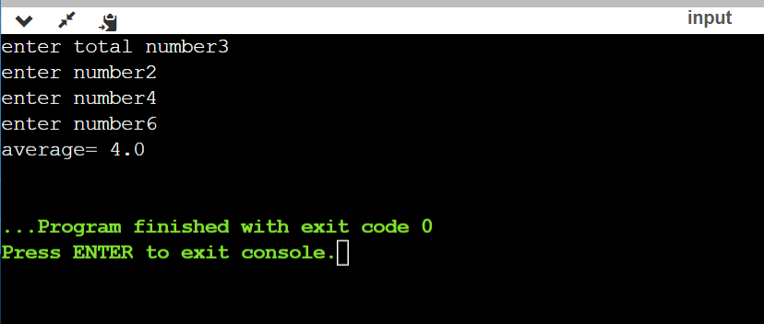

**Q5.** Write a python program to fill in a letter template given below with name and date.(Using string  
methods)  
Letter = ‘’’Dear </NAME>,  
You are selected!  
</DATE>’’’

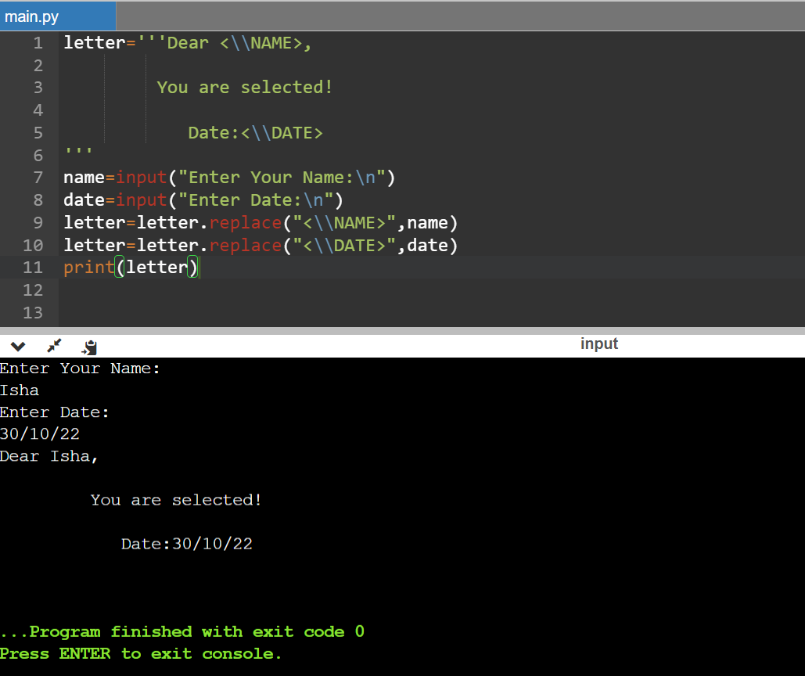

**Q6**. Write a program to

1. Sum a list with 10 numbers.  
   2) To count the number of zeros in the following tuple: a = (10, 0, 8, 0, 0, 1, 0)

1)

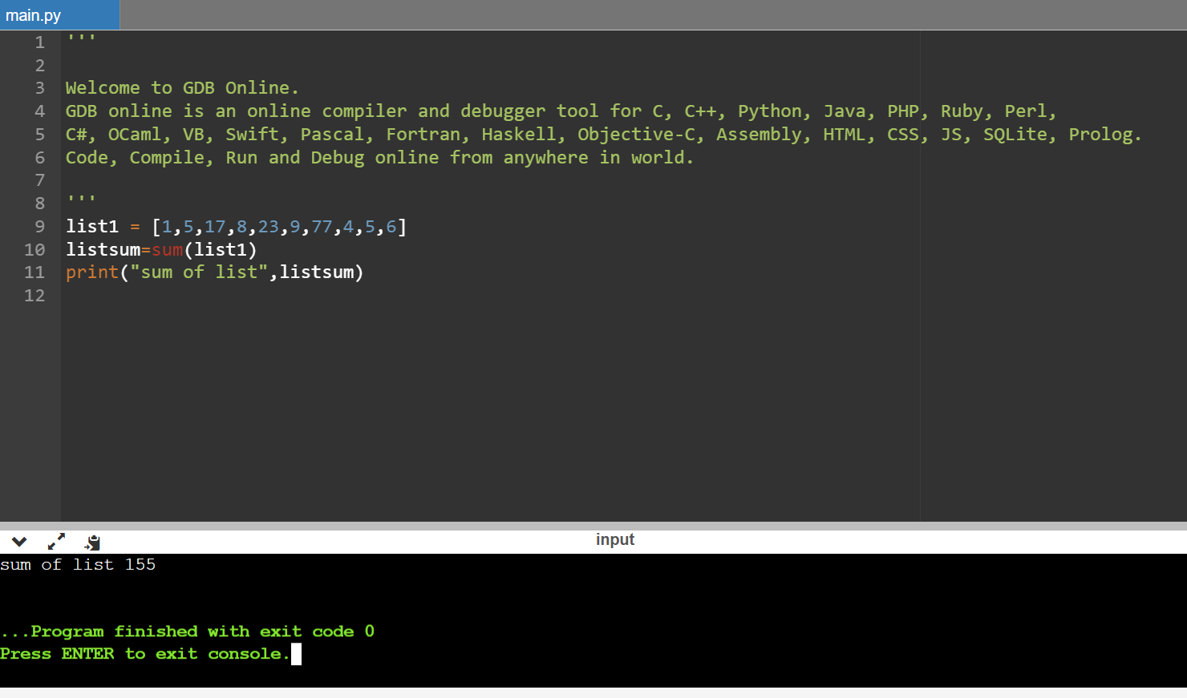

2)

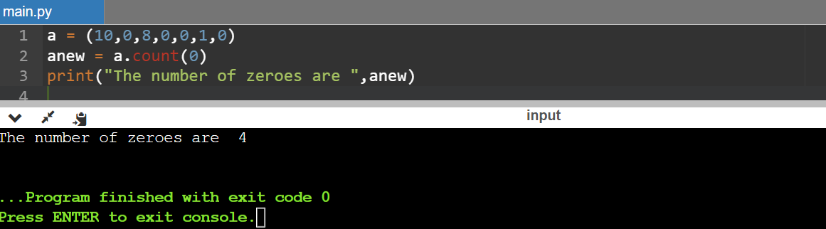

**Q7**. Create a dictionary with Hindi words as the key values and their corresponding English translation as values. Provide user with an option to look it up.

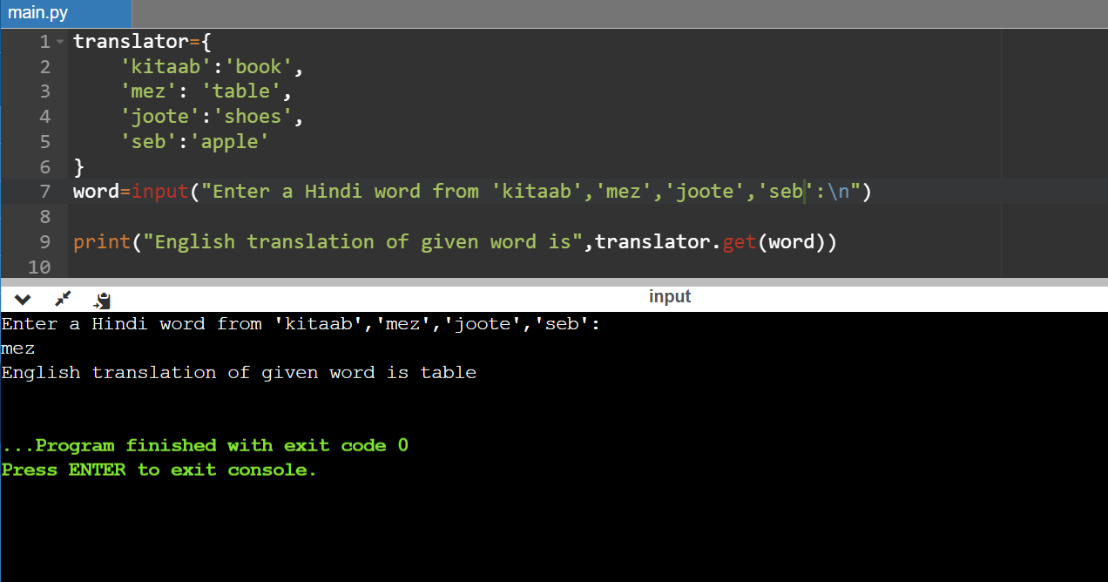

**Q8.** A spam comment is defined as a text containing following keywords:  
“Make a lot of money”, “buy now”, “subscribe this”, “and click this”. Write a python program to detect  
these spams.

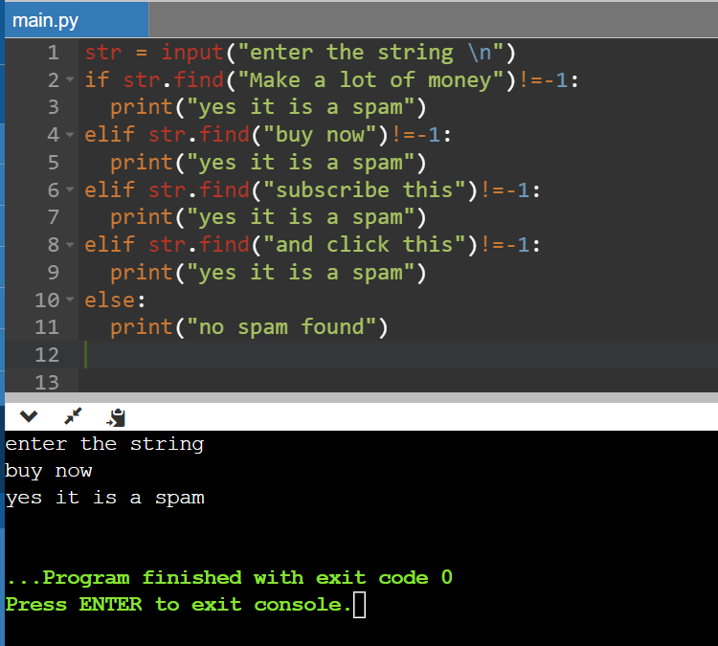

Q10.Write a python program to print the following star pattern: for n = 3  
* * *  
* *  
* * *

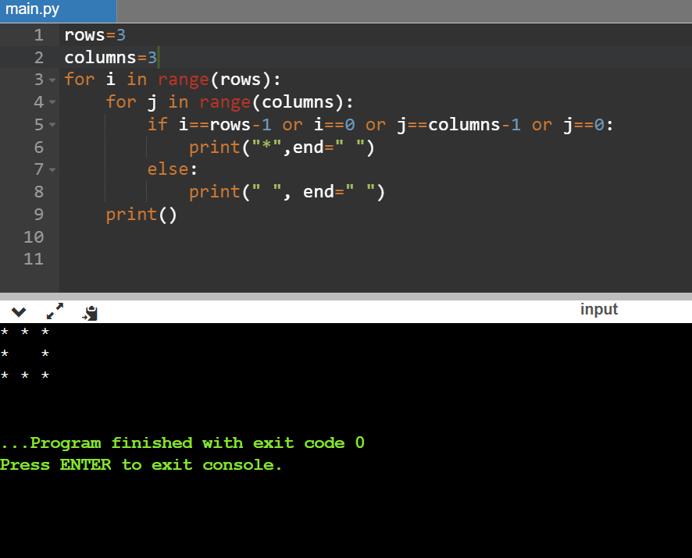

**Q11**. Write a recursive function to calculate the sum of the cube of the first n natural numbers.

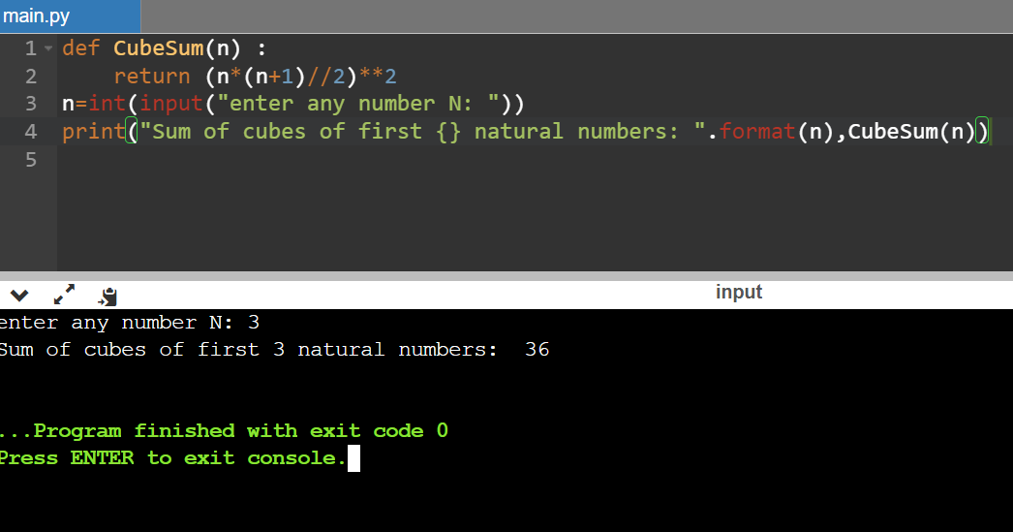

**Q12**. Write a python program to count the number of positive integers and negative integers in a list.

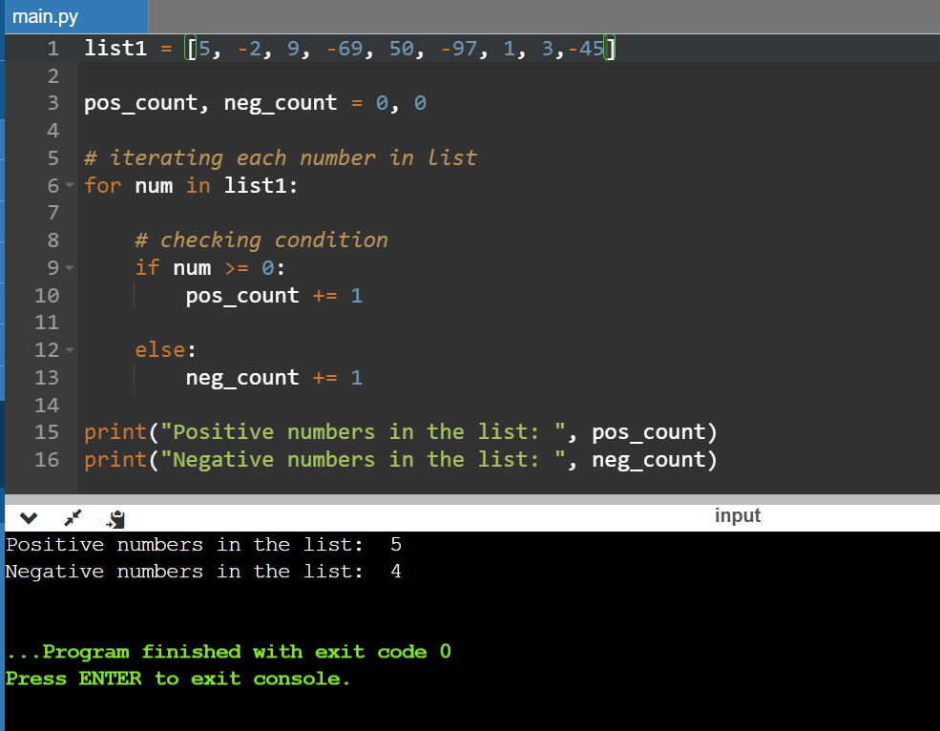

**Q13.** Write a python program to print all the elements with frequency count greater than k.

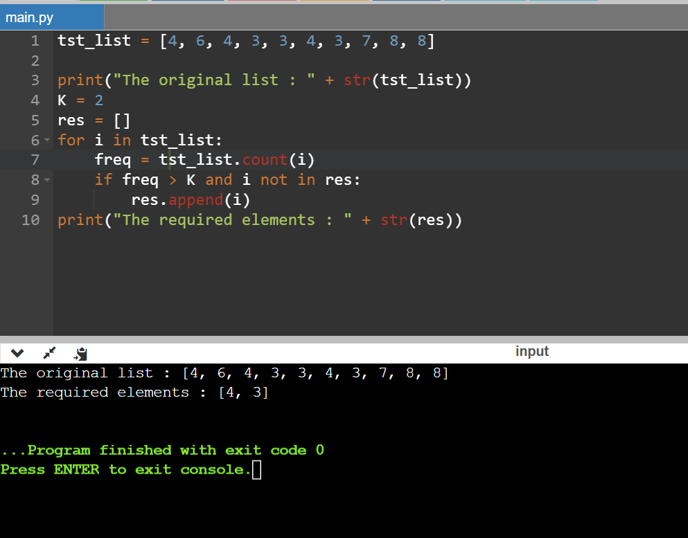

**Q14**. Write a python program to convert a given decimal number into binary , octal and hexadecimal  
numbers.

**Ans** def decimal_into_binary(decimal_1):

decimal = int(decimal_1)

print (" The given decimal number", decimal, "in Binary number is: ", bin(decimal))

def decimal_into_octal(decimal_1):

decimal = int(decimal_1)

print ("The given decimal number", decimal, "in Octal number is: ", oct(decimal))

def decimal_into_hexadecimal(decimal_1):

decimal = int(decimal_1)

print ("The given decimal number", decimal, " in Hexadecimal number is: ", hex(decimal))

decimal_1 = int (input (" Enter the Decimal Number: "))

decimal_into_binary(decimal_1)

decimal_into_octal(decimal_1)

decimal_into_hexadecimal(decimal_1)

**Q15.**Create a 5X2 integer array from a range between 100 to 200 such that the difference between each element is 10 using numpy.

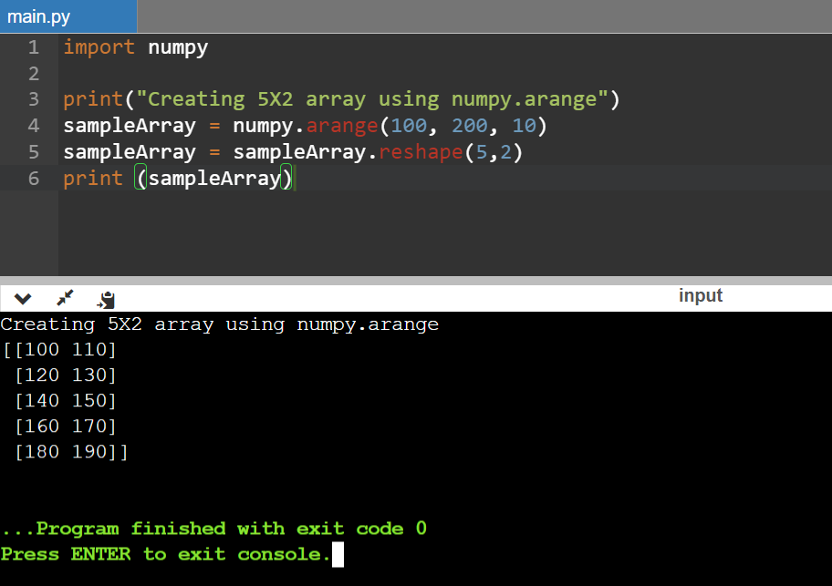

**Q16**. A website requires the users to input username and password to register. Write a program to check the validity of password input by users.

Following are the criteria for checking the password:  
1. At least 1 letter between [a-z]  
2. At least 1 number between [0-9]  
1. At least 1 letter between [A-Z]  
3. At least 1 character from [$#@]  
4. Minimum length of transaction password: 6  
5. Maximum length of transaction password: 12  
Your program should accept a sequence of comma separated passwords and will check them according  
to the above criteria. Passwords that match the criteria are to be printed, each separated by a comma.  
Example  
If the following passwords are given as input to the program:  
ABd1234@1,a F1#, 2w3E*, 2We3345  
Then, the output of the program should be:

ABd1234@1

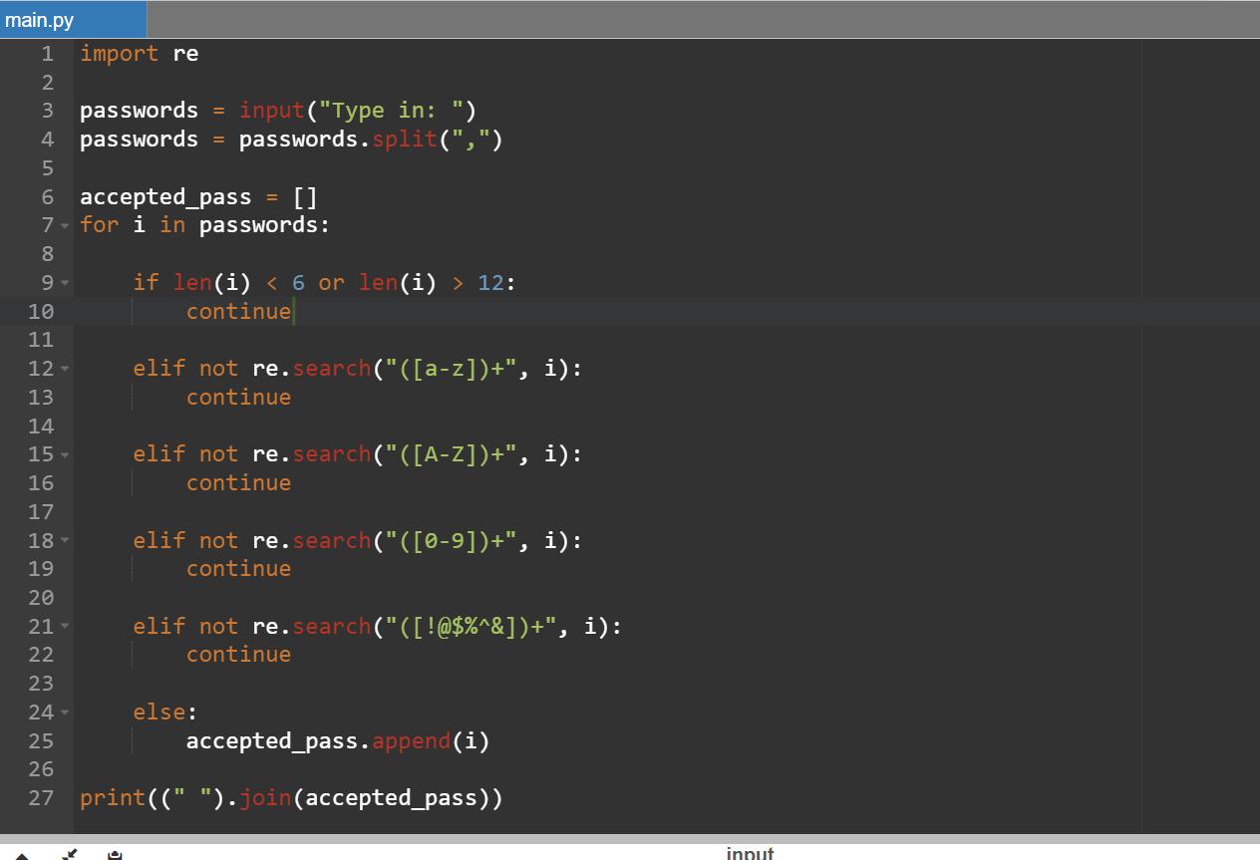

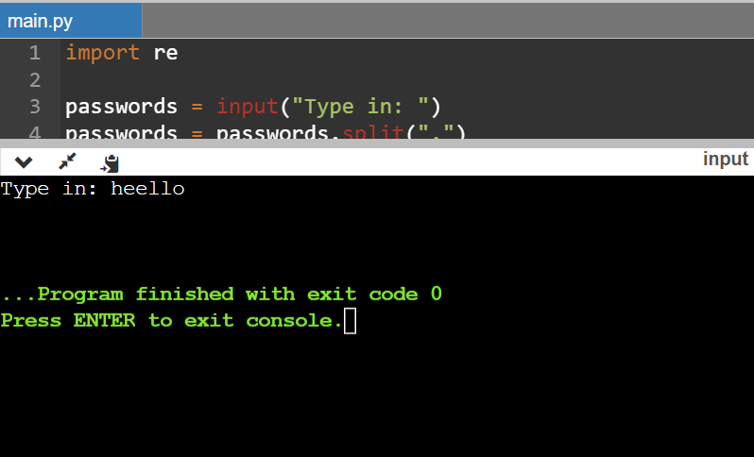

**Q17.** Define a function which can print a dictionary where the keys are numbers between 1 and 20(both  
included) and the values are square of keys

**Ans** d=dict()

for x in range(1,21):

d[x]=x**2

print(d)

**Q18.** Write a program which accepts a sequence of words separated by whitespace as input to print the  
words composed of digits only.  
Example:  
If the following words are given as input to the program:  
2 cats and 3 dogs.  
Then, the output of the program should be:  
['2', '3']  
In case of input data being supplied to the question, it should be assumed to be a console input.

**Ans** import re

email = input()

pattern = "\d+"

ans = re.findall(pattern,email)

print(ans)

**Q19.** The Fibonacci sequence is computed based on the following formula:  
f(n)=0 if n=0  
f(n)=1 if n=1  
f(n)=f(n-1)+f(n-2) if n>1  
Please write a program using list comprehension to print the Fibonacci Sequence in comma separated  
form with a given n input by console.  
Example:  
If the following n is given as input to the program:  
7  
Then, the output of the program should be:  
0, 1, 1,2,3,5,8,13

**Ans** n = int(input())

baseList = [0,1]

for i in range(2, n):

baseList.append(baseList[i-1] + baseList[i-2])

print(baseList**)**

**Q20.** Write a program to print the running time of execution of "1+1" for 100 times.

**Ans** from timeit import Timer

t = Timer("for i in range(100):1+1")

print (t.timeit())